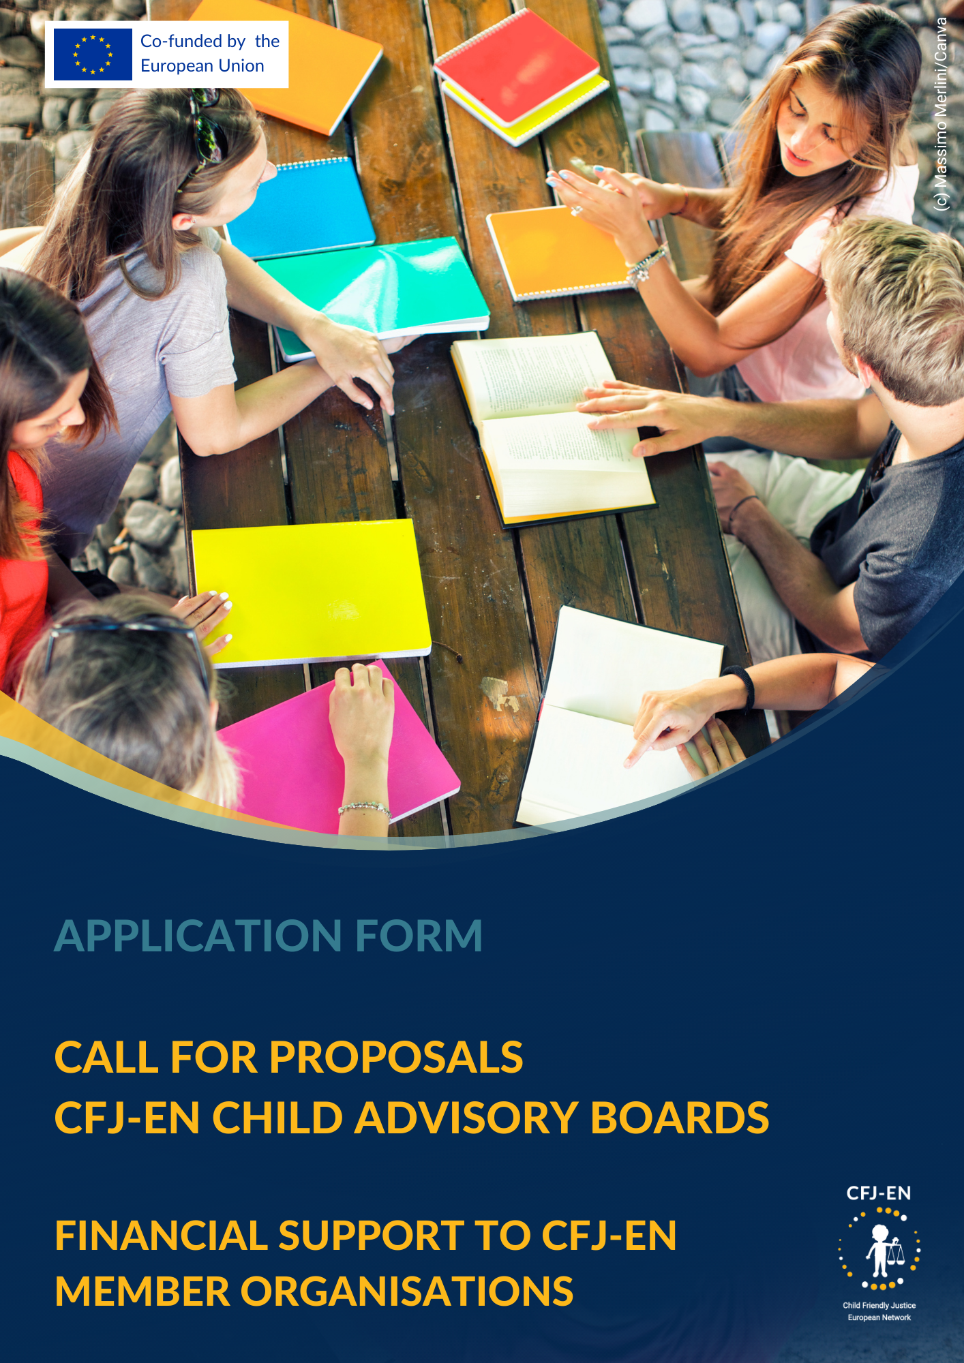

Table of Contents
Background 3
CFJ-EN Application Form 3
General Information 3
Project Sheet 4
Conflicts of interest 4
Operational capacity 5
Past projects 5
Pre-constituted groups of children/young people 5
Staff 5
Quality 6
Relevance 6
Methodology 6
Activities 7
Participatory dimension 8
Support to children 9
Inclusion 9
Child Protection and Safeguarding Policy 9
Risks Analysis 10
EU Values 10
Budget 11
Impact & Sustainability 12
Impact 12
Sustainability 12
CFJ-EN Application Checklist 12
Contact 13

Background
The CFJ-EN makes it a priority to empower children to have their rights respected in judicial proceedings, to collect in a participatory manner their voices and make them heard, and to build their capacity to become advocates of their rights (CFJ-EN’s 2023-2025 Strategic Plan, Strategic Priority 1: ‘Strengthening Children’s Agency’).
This sub-granting call answers the objective to increase the participation of children in CFJ-EN’s member organisations and at the Network’s governance level. Through this project proposal for Child Advisory Boards (CAB), the CFJ-EN will support 3 to 4 member organisations with a budget from 15.542 € up to 20,722€ each, depending on the number of CAB projects.

CFJ-EN Application Form
 | General Information
 | Legal name of organisation
 | Acronym or short name
 | Country of establishment
 | IBAN
 | BIC code
 | VAT number
 | Full name of legal representative
 | Function of legal representative
 | Full name of contact person for this project
 | Function of contact person
 | Email address of contact person
 | Do you have a Child Protection and Safeguarding Policy? | ☐ Yes / ☐ No  * If yes, please send it together with your application
 | Are you a full member of the CFJ-EN? | ☐ Yes / ☐ No  *This call is only open to CFJ-EN full member organisations

Project Sheet
Title of the project
Summary Description of the project
(max 300 words)
Requested budget (in euros)

Conflicts of interest
Is any of the staff involved in the proposal a current staff or board member of DCI Belgium? If so, please explain.
☐ YES ☐ NO
………………………………………………………………………………………………..

Is any of the staff involved in the proposal a family member of a current staff or board member of DCI Belgium? If so, please explain.
☐ YES ☐ NO
………………………………………………………………………………………………..

Is any of the staff involved in the proposal a family member of a member of the review committee for the sub-granting call? If so, please explain.
☐ YES ☐ NO
………………………………………………………………………………………………..

Do you have any private business activity or personal services with DCI Belgium? If so, please explain.
☐ YES ☐ NO
………………………………………………………………………………………………..

Operational capacity

Past projects
Please fill in the table below with past projects your organisation was involved in relevant to child participation/child empowerment.
Name of the project | Brief description of the project’s participatory dimension | Link to the project’s webpage (if available)
*Please add as many lines as needed

Pre-constituted groups of children/young people
Please fill indicate groups of children and young people your organisation is already working with (e.g. created during past projects and still operating)
Name of the group | Brief description of the group’s objectives/context of creation
*Please add as many lines as needed

Staff
Please fill in the table below with the name and position of staff members involved in the project. If you are looking to hire one of the positions, please indicate the position below. Do not forget to attach CVs of each staff member or job descriptions for positions to be filled, and their engagement document including signature of the Child Protection and Safeguarding Policy.
Full Name | Position | CV attached
 |  | ☐
 |  | ☐
 |  | ☐
*Please add as many lines as needed
Are your relevant staff trained in child communication methods and participatory methods? If yes, briefly mention what training they received
Are your relevant staff trained on child and adolescent development principles? If yes, briefly mention what training they received

Quality

Relevance
Who are the target groups of your project?
How does your project contribute to building a child friendly justice system in your country?
How does your project contribute to achieving Strategic priority 1 of the CFJ-EN: ‘Strengthening Children’s Agency’?
Are there any additional objectives of your CAB you would like to mention?

Methodology
Briefly describe the methodology that you will use to conduct child advisory boards.

What profile of children and young people do you expect to participate in the CAB (age, gender, background, etc.)?
How often will your CAB meet? Briefly describe how a typical meeting would be conducted.
How would the children and young people be accompanied by adults (facilitators, participation experts, trainers, etc.)?
Is there any additional information you would like to provide?

Activities
Please list below all project-related activities you will conduct and provide a brief description of each of them.
A1 – Activity 1
A2 – Activity 2
*Please add as many lines as needed
Please fill in the suggested timeline of your project
Activity | M1 | M2 | M3 | M4 | M5 | M6 | M7 | M8 | M9 | M10 | M11 | M12
A1
A2
A3
…
*Please add as many lines as needed

Participatory dimension
Please describe how children and young people will be able to give inputs on the format, schedule, content and outputs of the CAB?
Please describe the complaints and feedback mechanism you plan to put in place while running the CAB.
Is there any additional information you would like to provide?

Support to children
What services can your organisation or local partners offer to children and young people involved? (psychological support, legal advice, counselling, etc.)
Do you plan to compensate CAB participants for their time?If so, please describe by what means.
Is there any additional information you would like to provide?

Inclusion
How will children and young people be selected to be a part of the CAB?
How will you ensure non-discrimination in your project?
How will you ensure inclusion and accessibility of the CAB activities?
Is there any additional information you would like to provide?

Child Protection and Safeguarding Policy
Please do not forget to attach your organisation’s child protection and safeguarding policy.

Risks Analysis
Please list below any technical, operational, legal, financial risks associated with your project. | For each risk, please indicate mitigation measures and likelihood of the risk.
*Please add as many lines as needed

EU Values
Outline how your proposal complies with EU values (human dignity, freedom, democracy, equality, the rule of law, respect for human rights including the rights of persons belonging to minorities, non-discrimination, tolerance, justice, solidarity and gender equality), as expressed in Art. 2 of the Treaty on the European Union and Art. 21 of the EU Charter of Fundamental Rights.

Budget
Budget (in EUROS)
Activity | Cost Category | Unit cost Type | Unit Cost Value | Number of Units | Subtotal
A1 – Activity title | C1 | day, person, lump sum, flight, … | 30 | 100 | 3.000
TOTAL

*Please add as many lines as needed
For the ‘category’ column, please refer to art.6 of the Call listing eligible cost categories.

Impact & Sustainability

Impact
How will target groups benefit concretely from the project and what would change for them?
What is the expected impact (short, midterm, long-term) of your project on the advancement of child rights and child participation at the local or national level?
What is the expected impact (short, midterm, long-term) of your project on the advancement of child rights and child participation at the European level?

Sustainability
Do you have any concrete means to keep supporting CAB participants after the project ends, or after they cease to participate? Please provide examples
Is there any additional information you would like to provide?

CFJ-EN Application Checklist
In support of your application, kindly submit the following documents to info@cfjnetwork.eu:
☐ Filled application form (including description of the project, methodology, budget and experience)
☐ Child Protection and Safeguarding Policy
☐ CVs of the staff responsible for managing and implementing the project
Or job profile if the staff is not recruited yet

Contact
For any further information or inquiry in relation to this call, please contact:

Mariama Diallo, Coordinator, CFJ-EN: mariama.diallo@cfjnetwork.eu
Lise Brument, Coordination Assistant, CFJ-EN: lise.brument@cfjnetwork.eu

The CFJ-EN is co-funded by the European Union. Views and opinions expressed are however those of the author(s) only and do not necessarily reflect those of the European Union. Neither the European Union nor the granting authority can be held responsible for them.

The CFJ-EN is part of the legal entity and enjoys the support of :
Défense des Enfants International – Belgique
Rue Marché aux Poulets 30 – 1000 Bruxelles
N° entreprise : 0447.397.058 – RPM : Bruxelles
IBAN : BE89 0682 1223 2185
E: info@cfjnetwork.eu
W: www.cfjnetwork.eu T: +32 2 203 79 08
